# **Mastering Burp Suite and Metasploit**

## **Overview**

The objective of this project is to develop practical cybersecurity skills by completing 10+ labs from PortSwigger Academy, conducting controlled tests on real websites using Burp Suite, learning Ruby basics, and using tools like Metasploit, MSFvenom, and SearchSploit for vulnerability exploitation and payload generation.

## **Requirements**

**Burp Suite Proficiency**

* Complete 10+ labs from PortSwigger Academy to master web vulnerability testing.

**Controlled Website Testing**

* Perform legal, controlled security tests on real websites using Burp Suite tools.

**Tool Usage Documentation**

* Identify tools for specific tasks and document their use, including rationale.

**Ruby Basics**

* Learn Ruby for scripting and integrating with cybersecurity workflows.

**Metasploit Usage**

* Use Metasploit modules to exploit vulnerabilities in practice environments like Metasploitable or TryHackMe.

**Payload Generation with MSFvenom**

* Create and obfuscate payloads using MSFvenom to bypass detection.

**Exploit Search with SearchSploit**

* Leverage SearchSploit for finding and using CVEs in testing scenarios.

**Burp Suite Proficiency**

## SQL injection attack, listing the database contents on non-Oracle databases

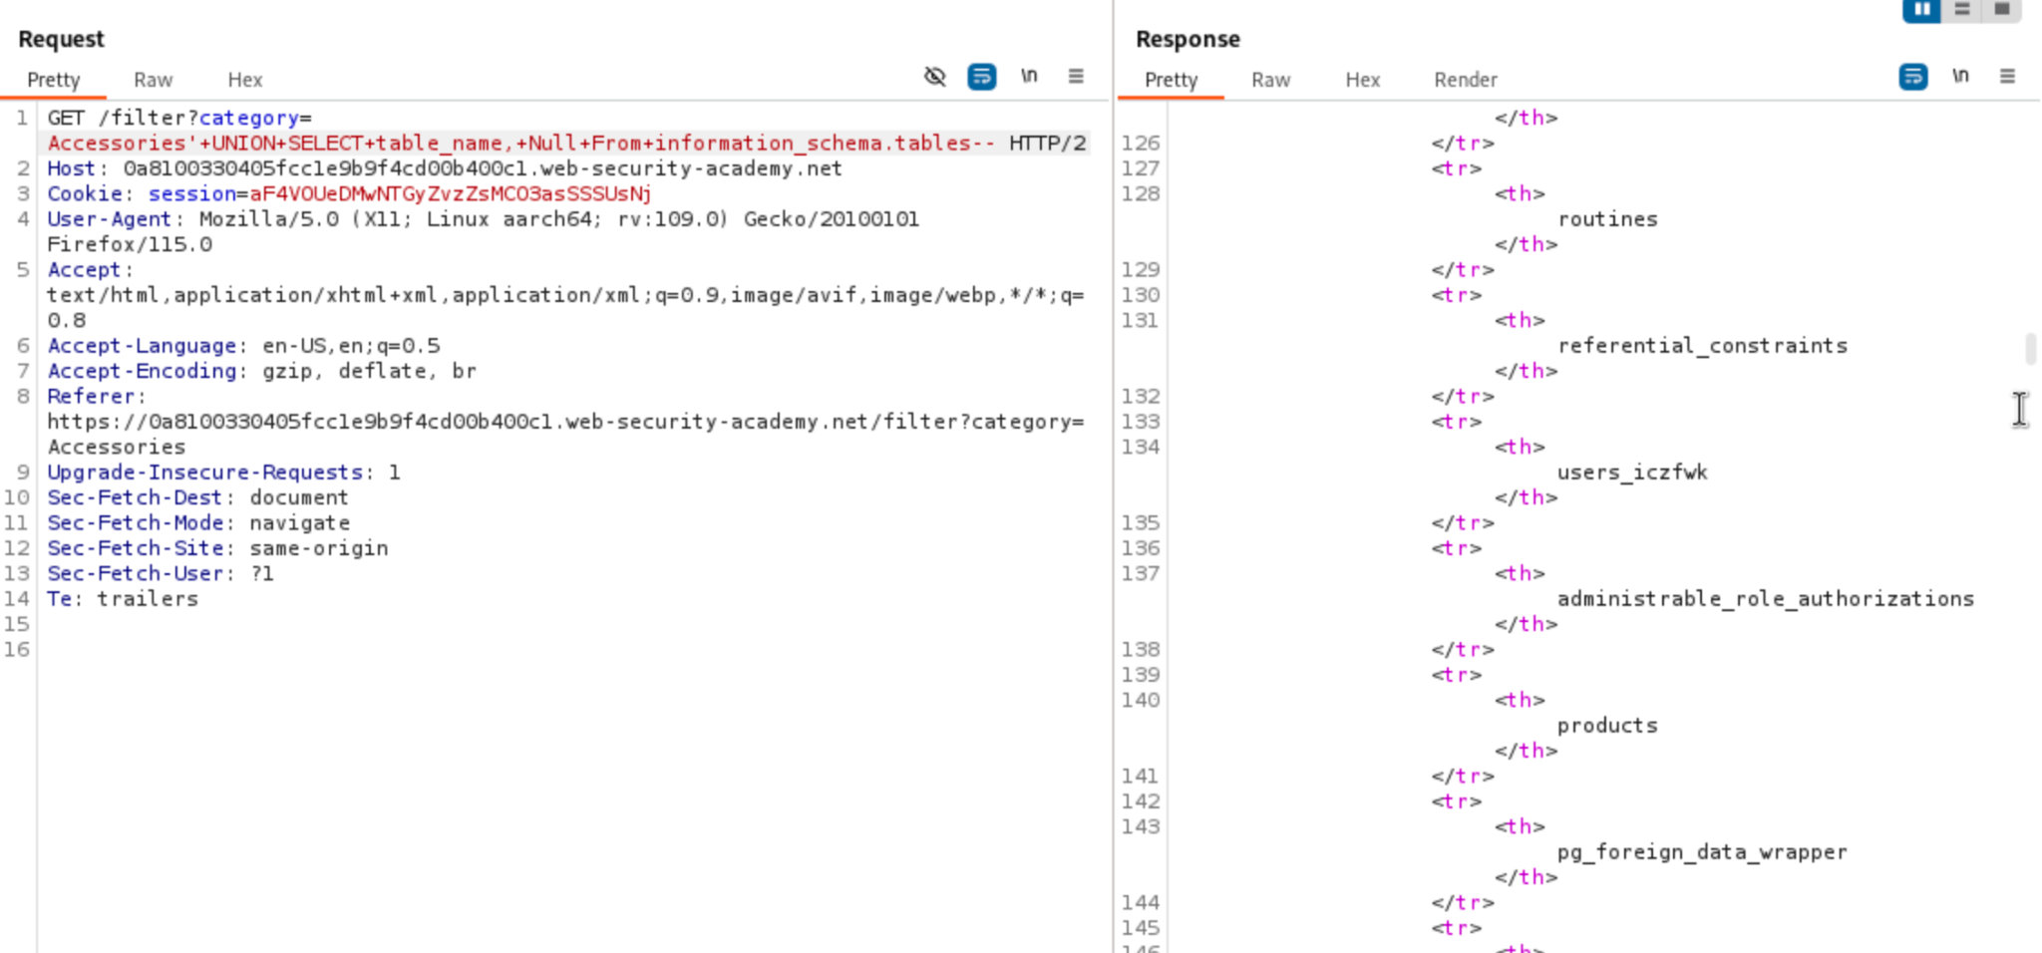

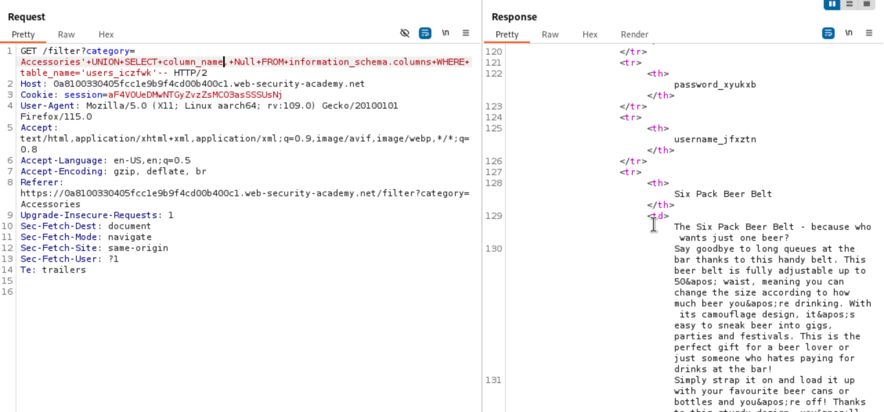

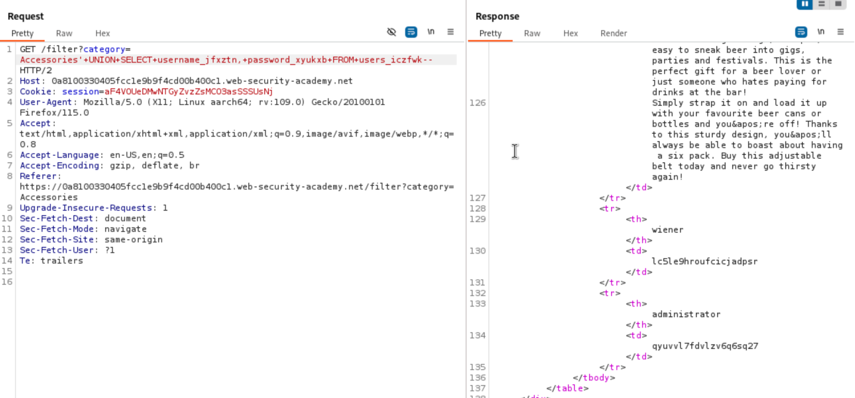

## SQL injection attack, querying the database type and version on MySQL and Microsoft

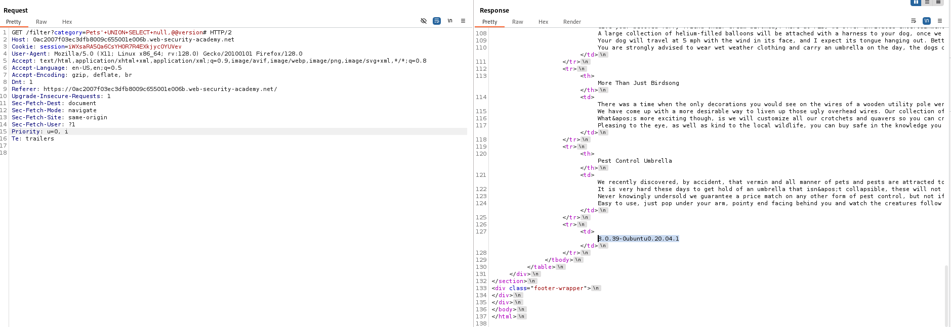

# SQL injection attack, querying the database type and version on Oracle

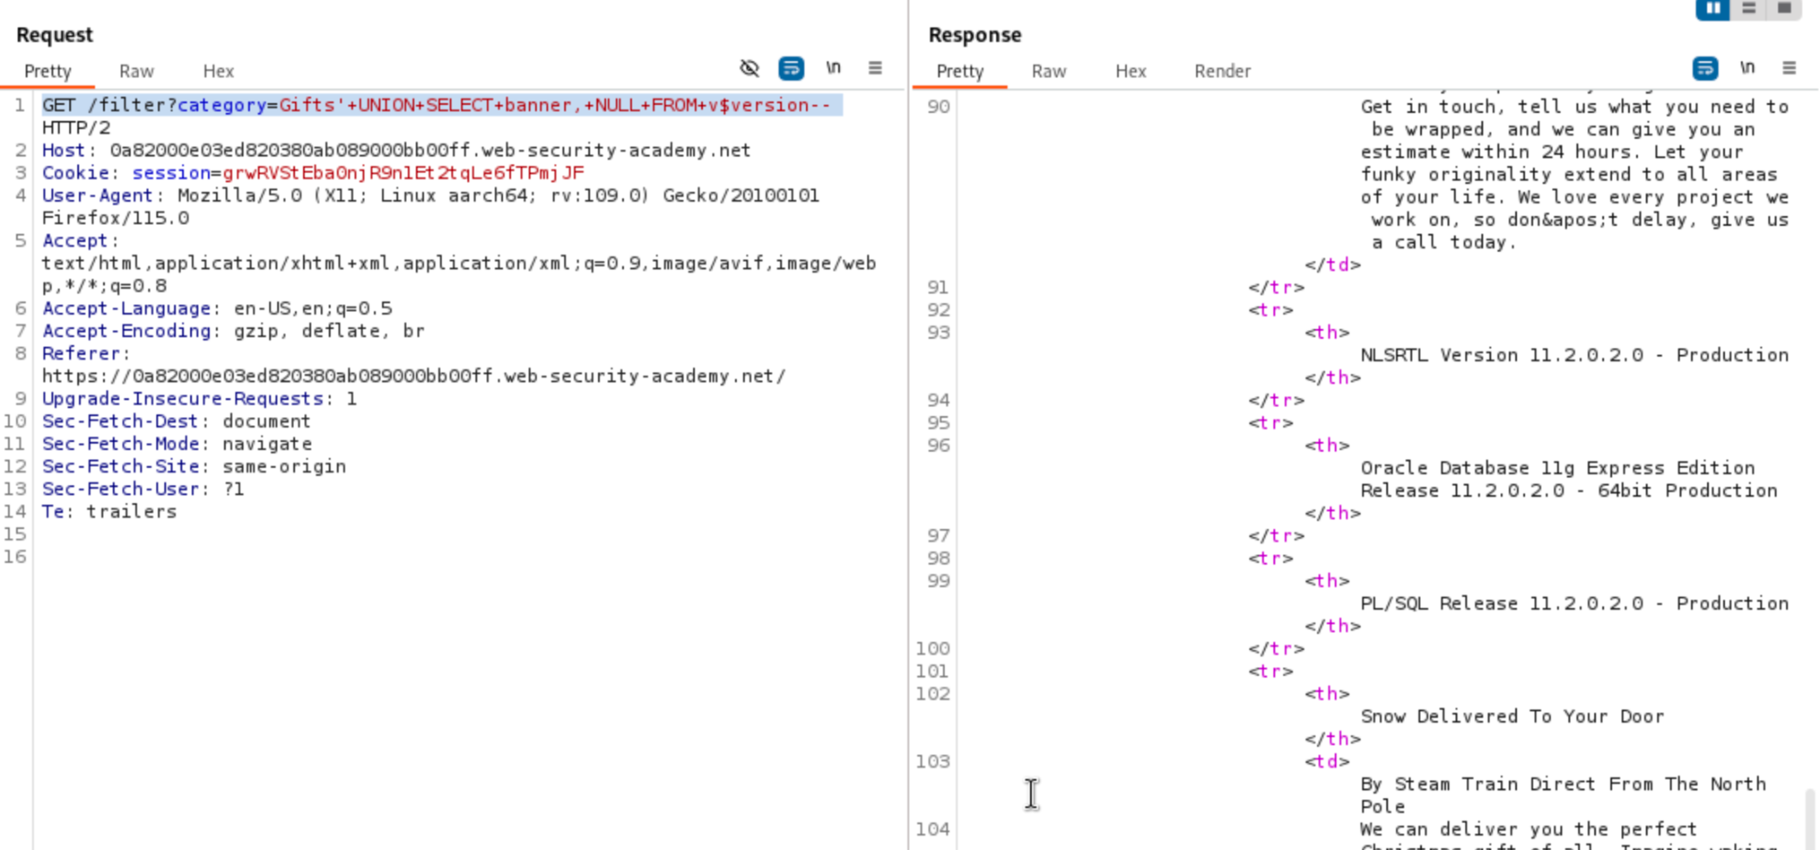

# DOM XSS in AngularJS expression with angle brackets and double quotes HTML-encoded

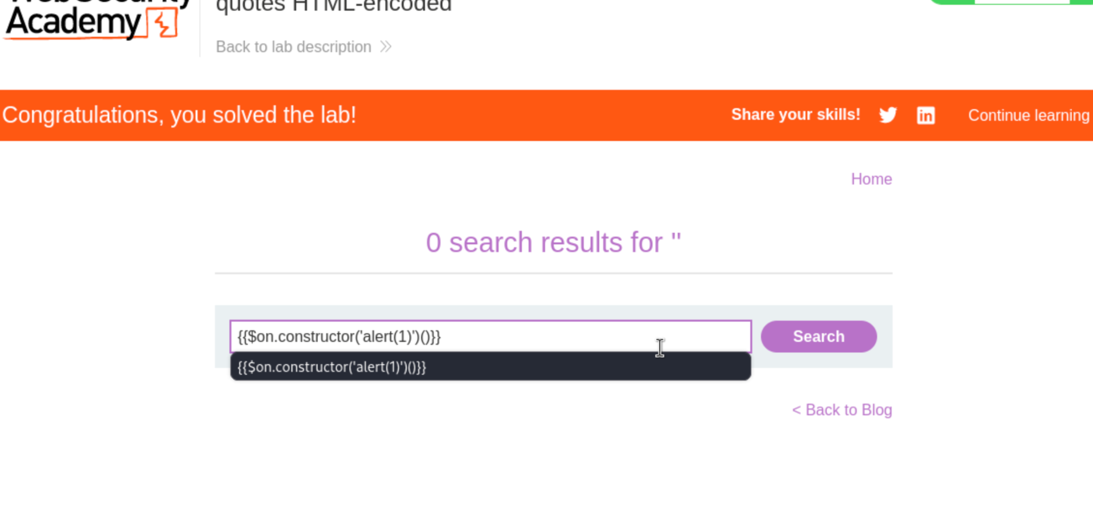

# Reflected XSS into HTML context with most tags and attributes blocked

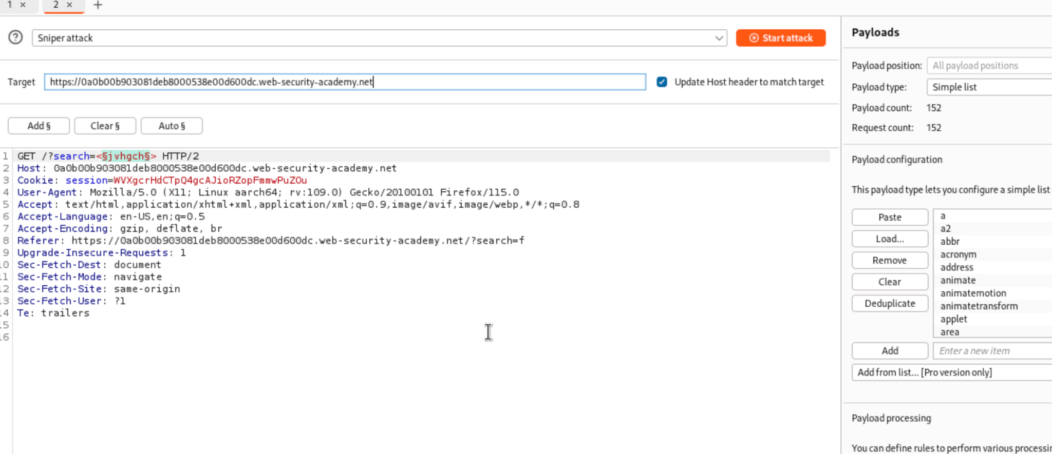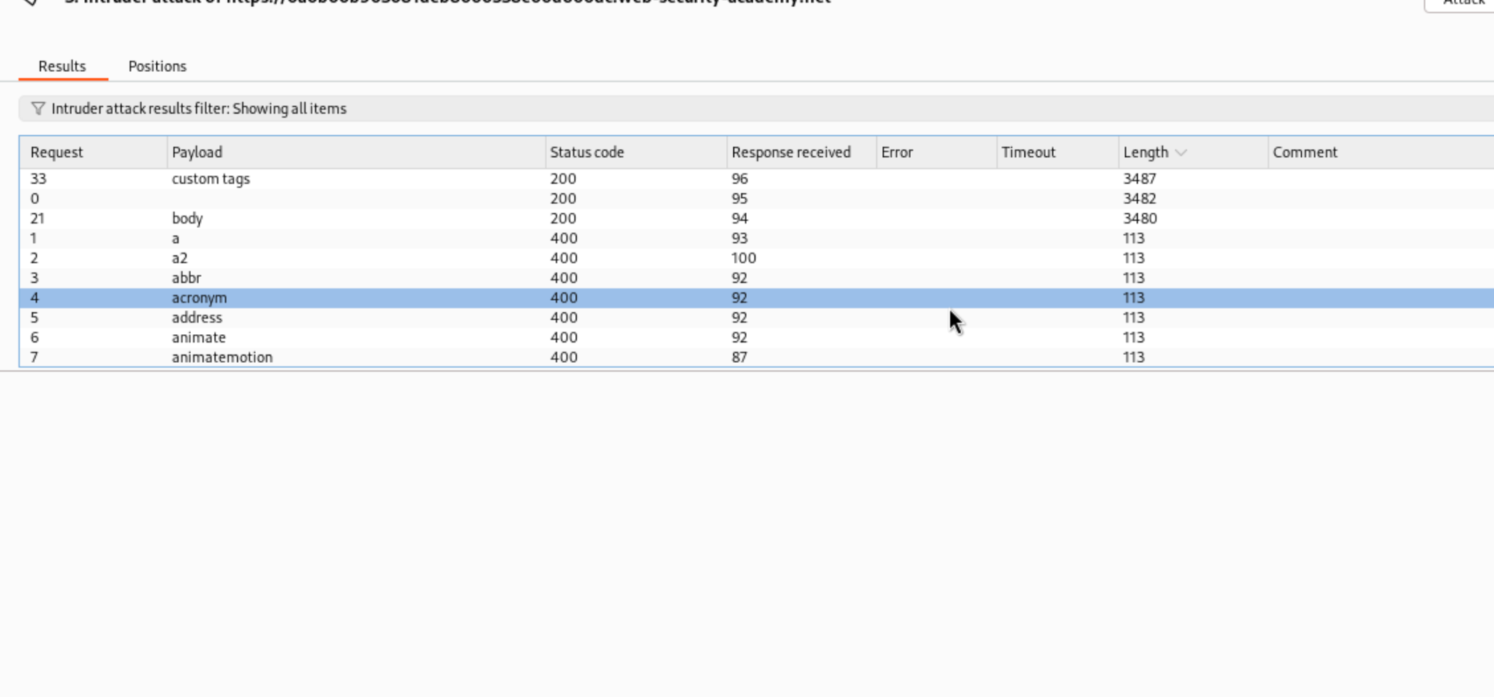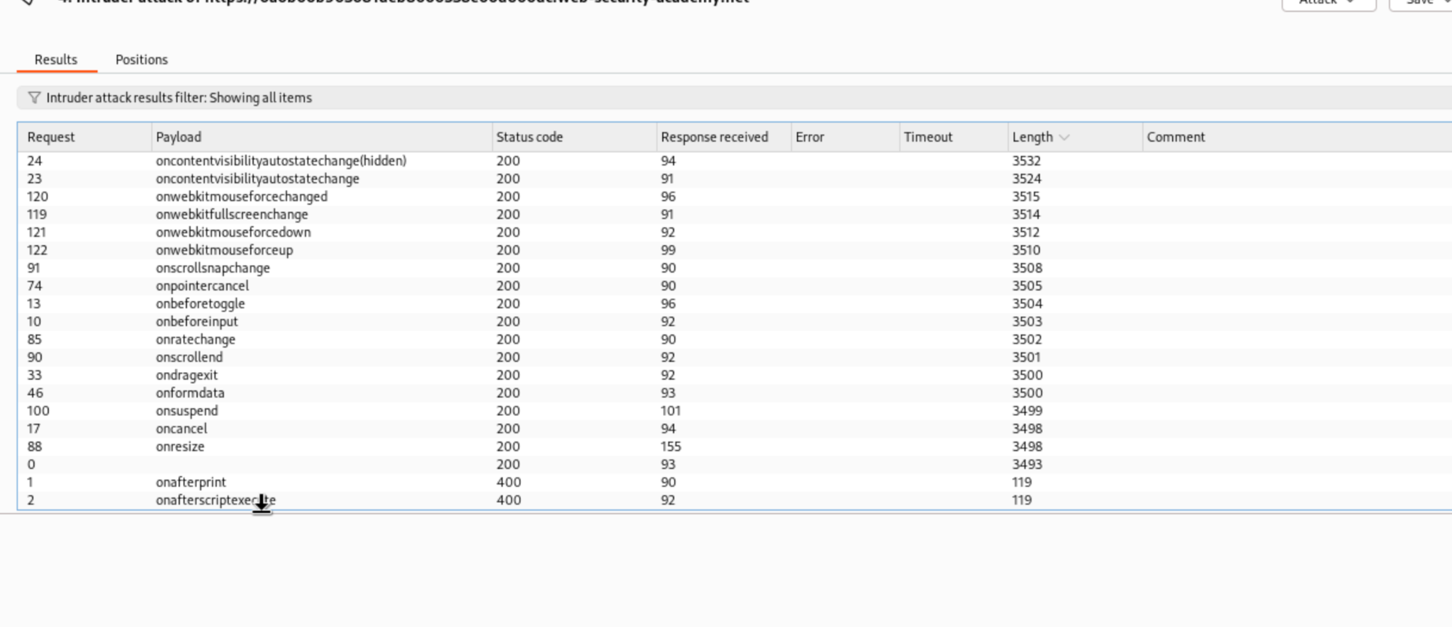

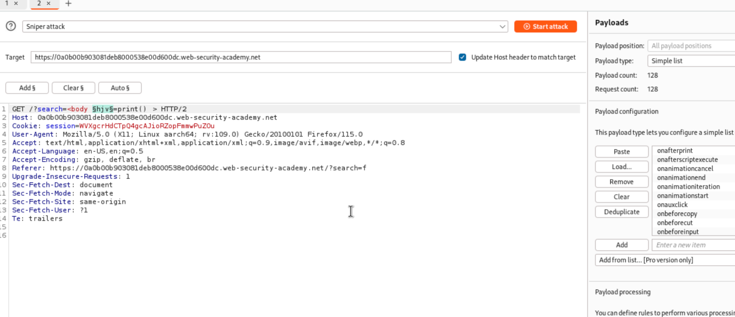

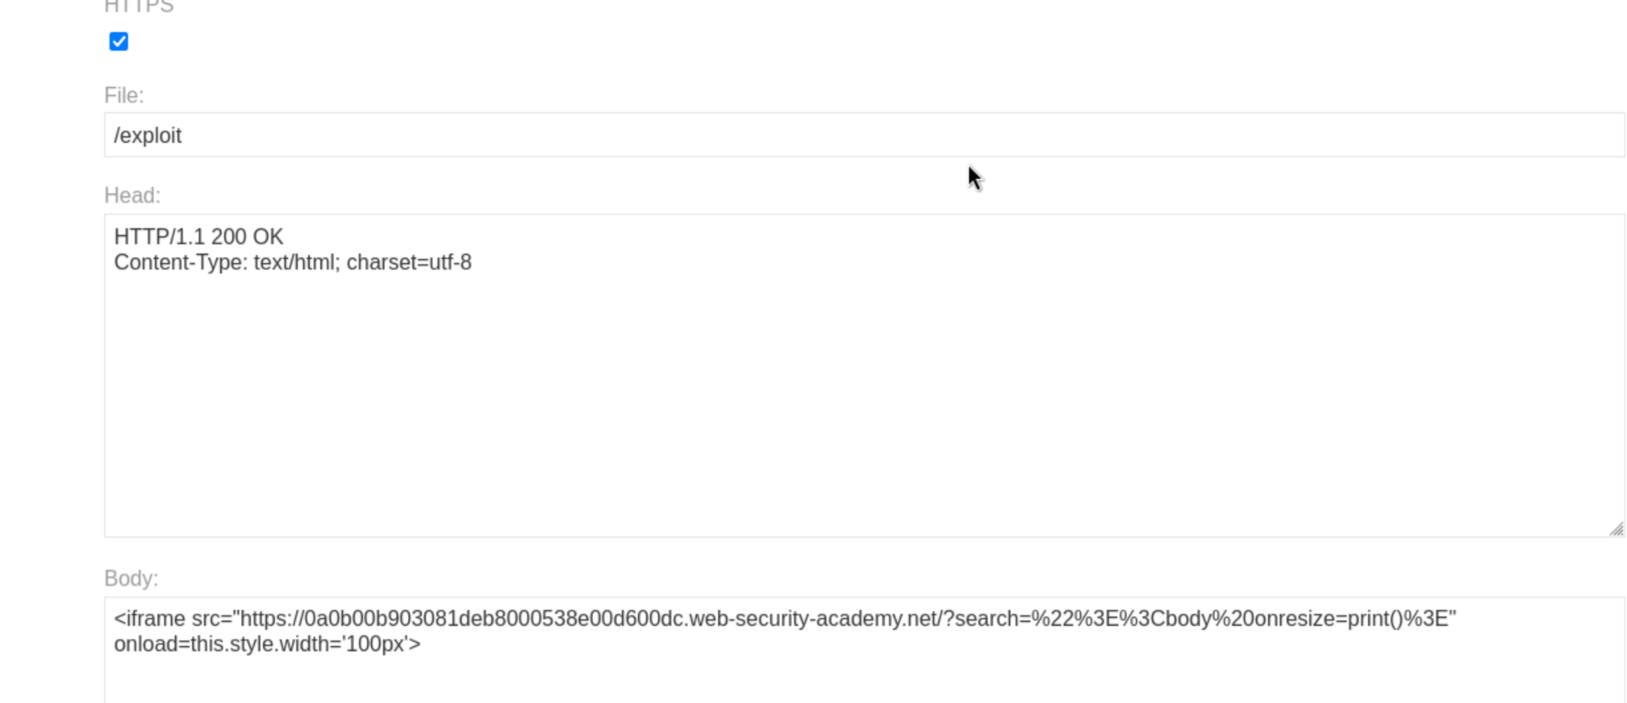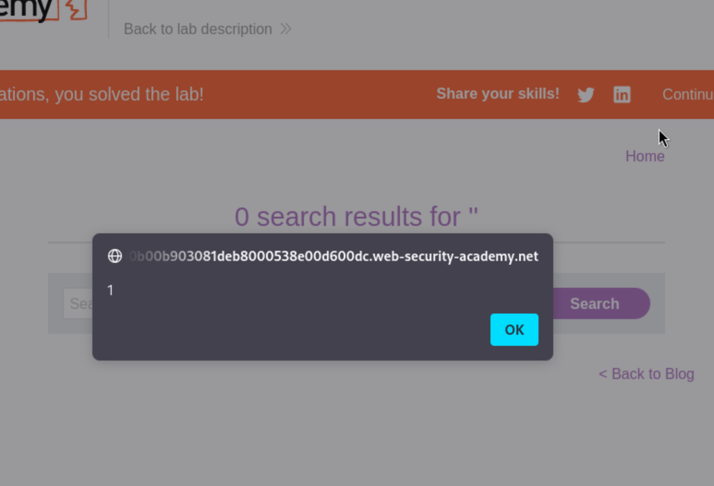

# Exploiting cross-site scripting to steal cookies

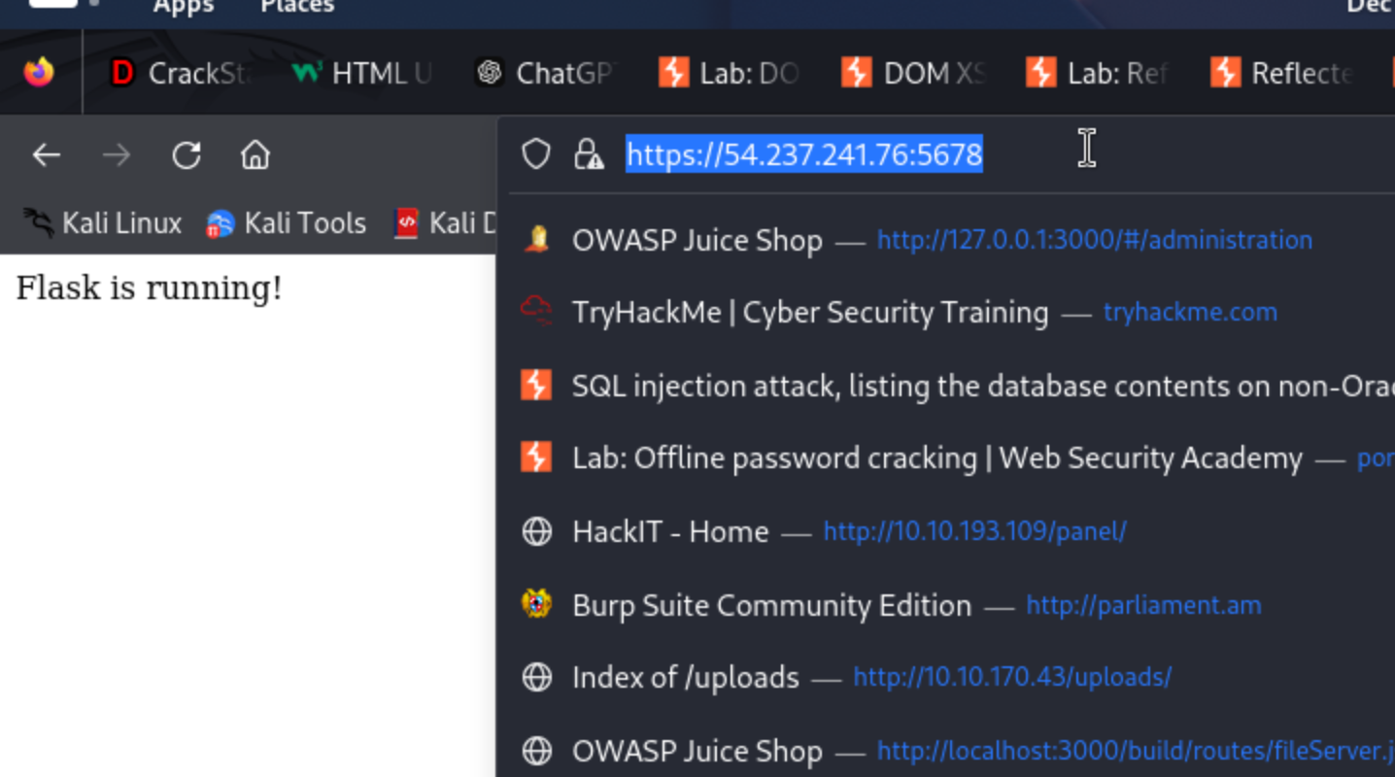

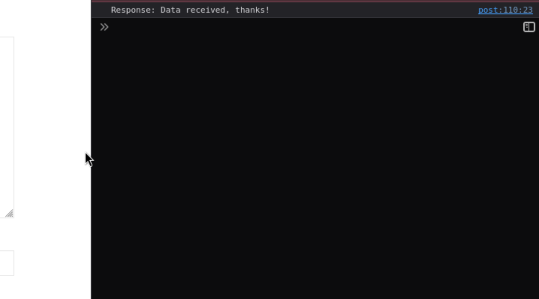

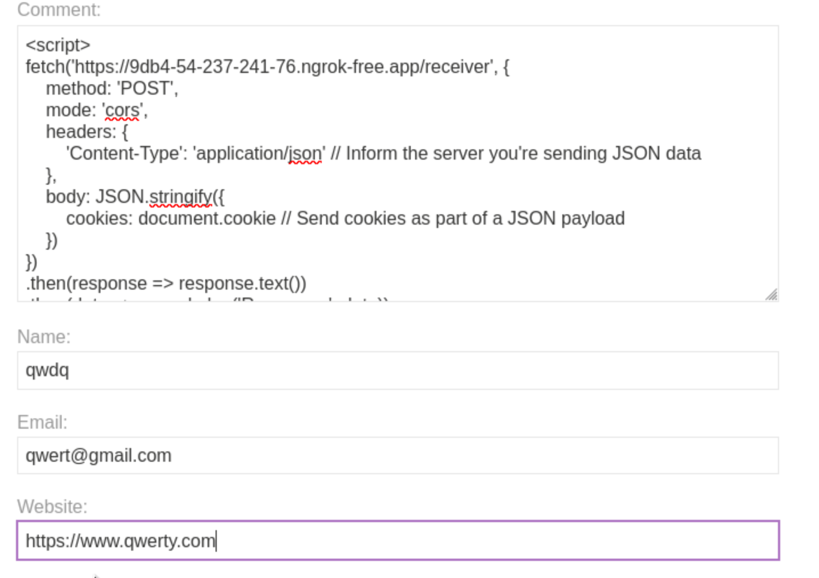

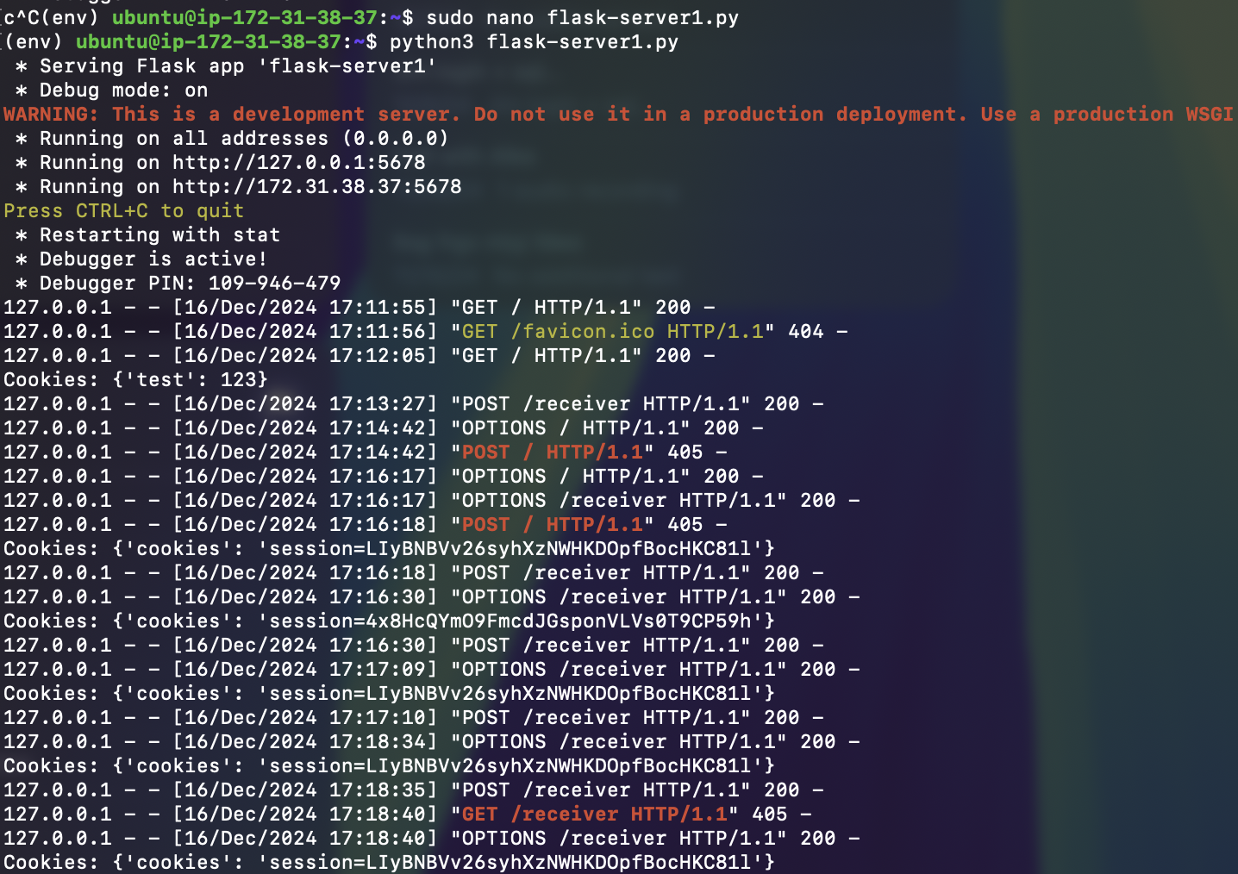

# CSRF where token validation depends on request method

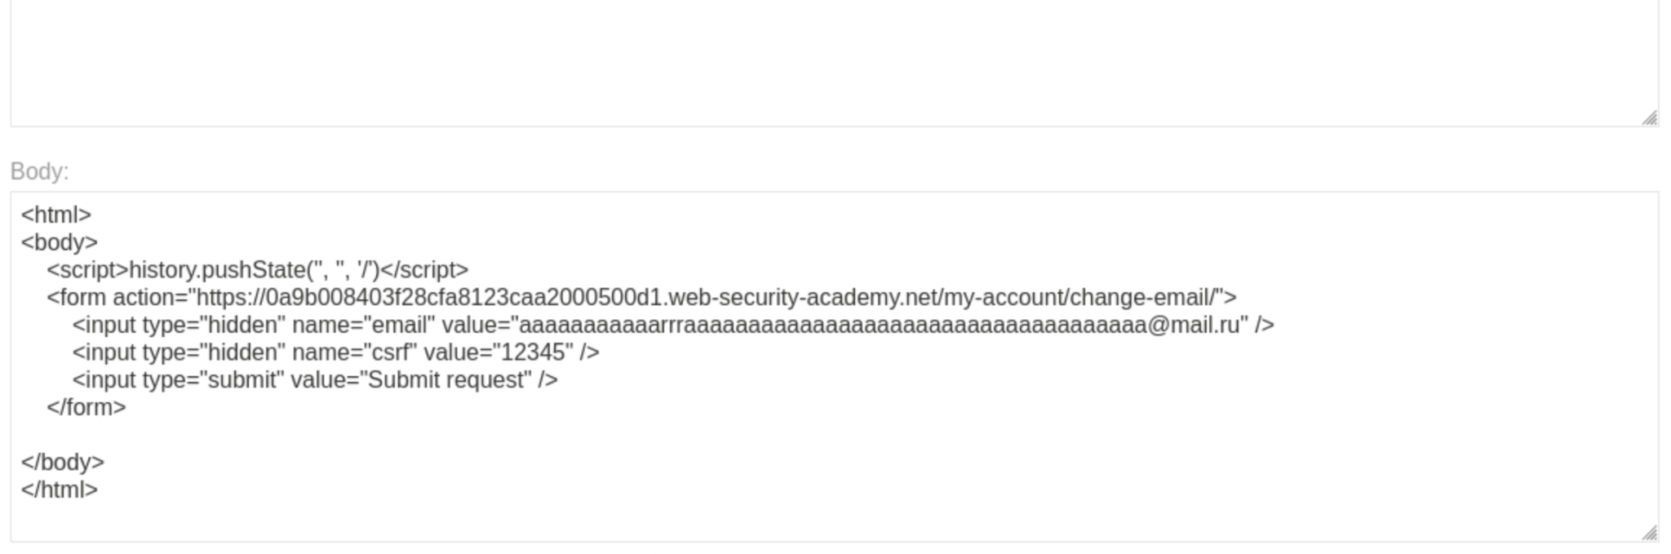

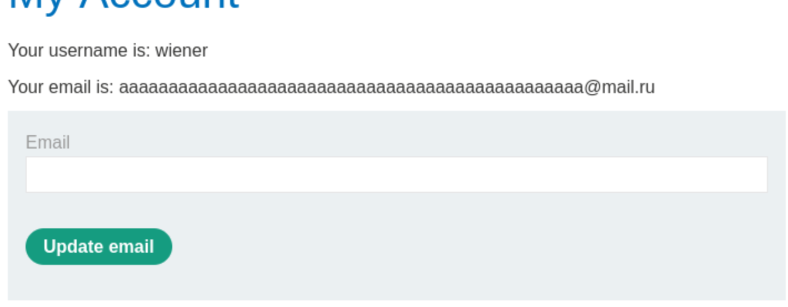

# CSRF where token validation depends on token being present

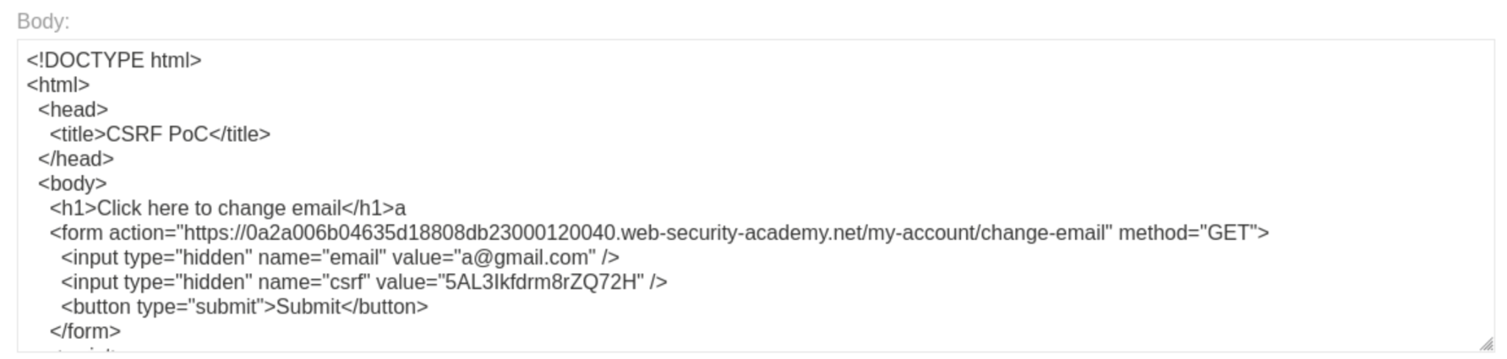

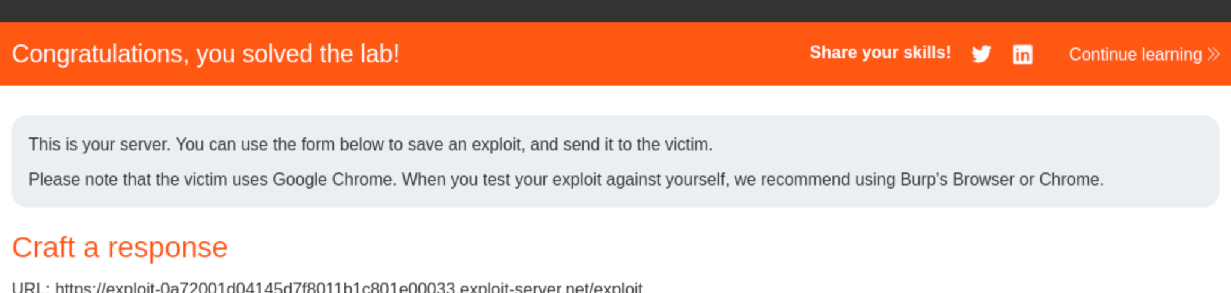

# CSRF where token is not tied to user session

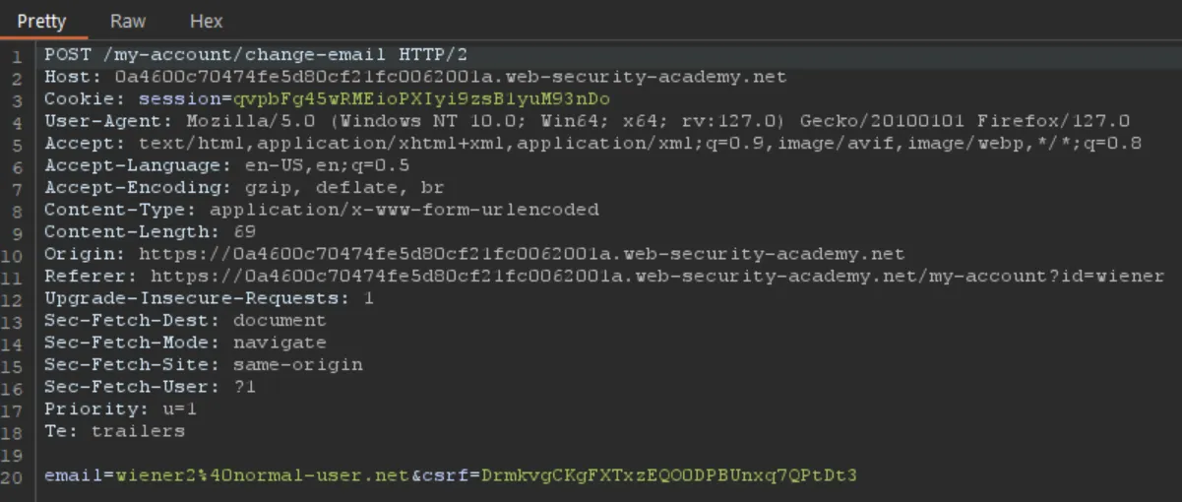

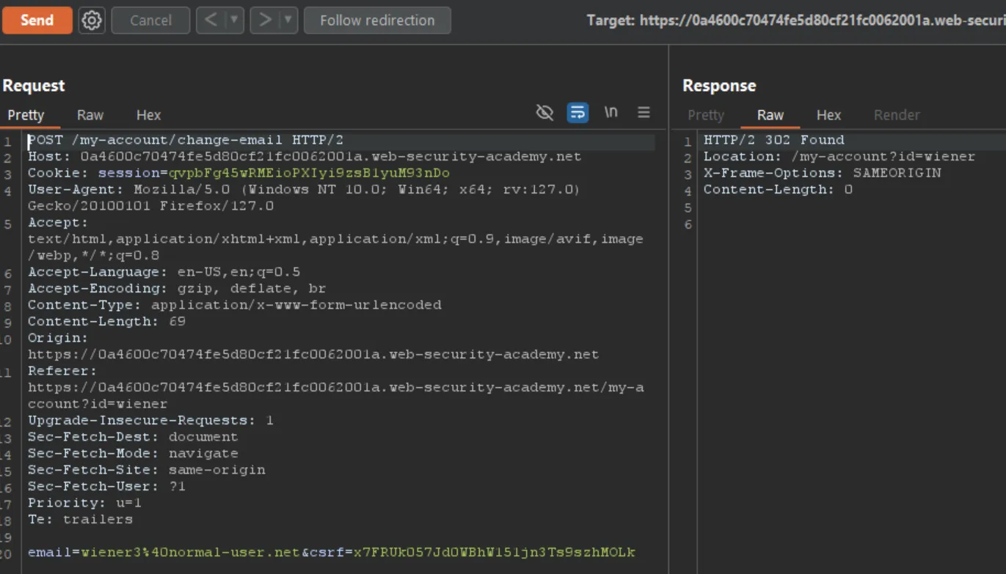

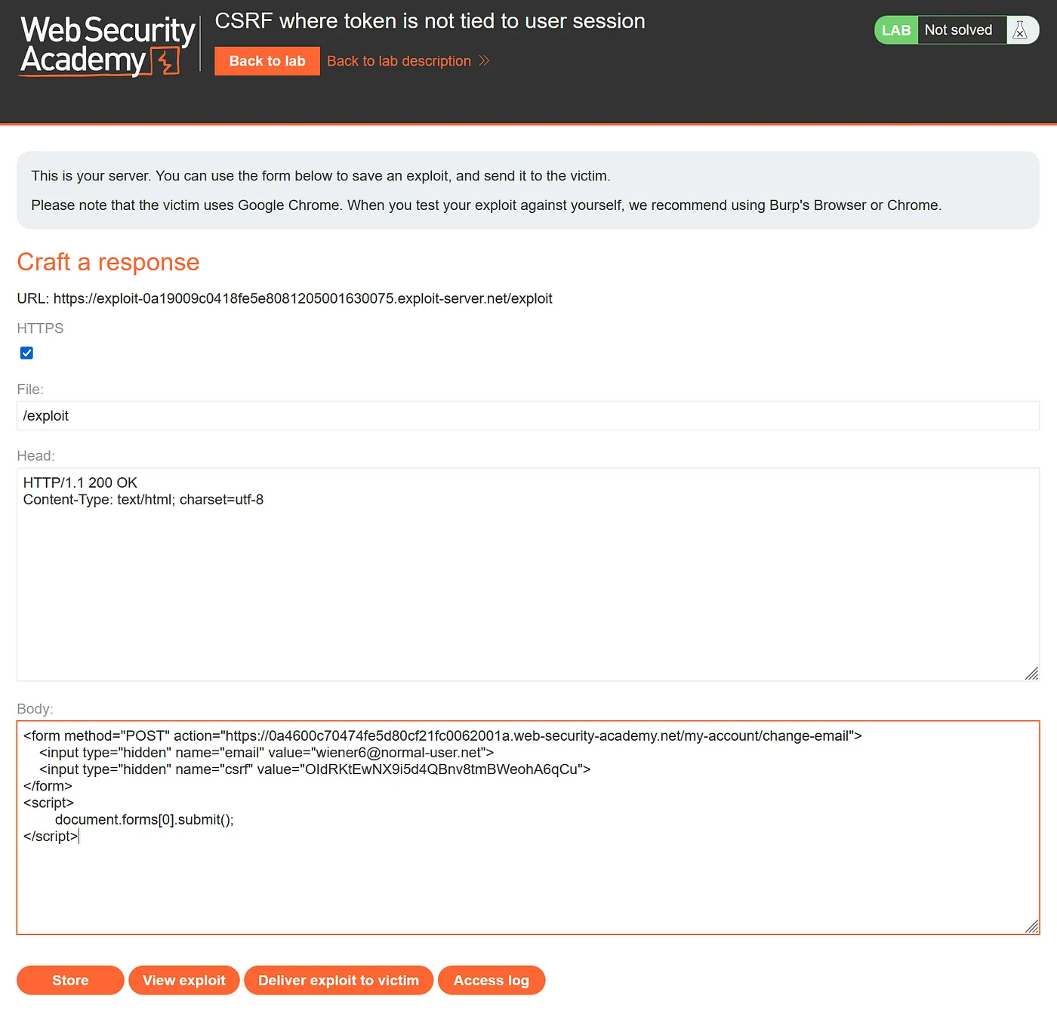

# Blind OS command injection with time delays

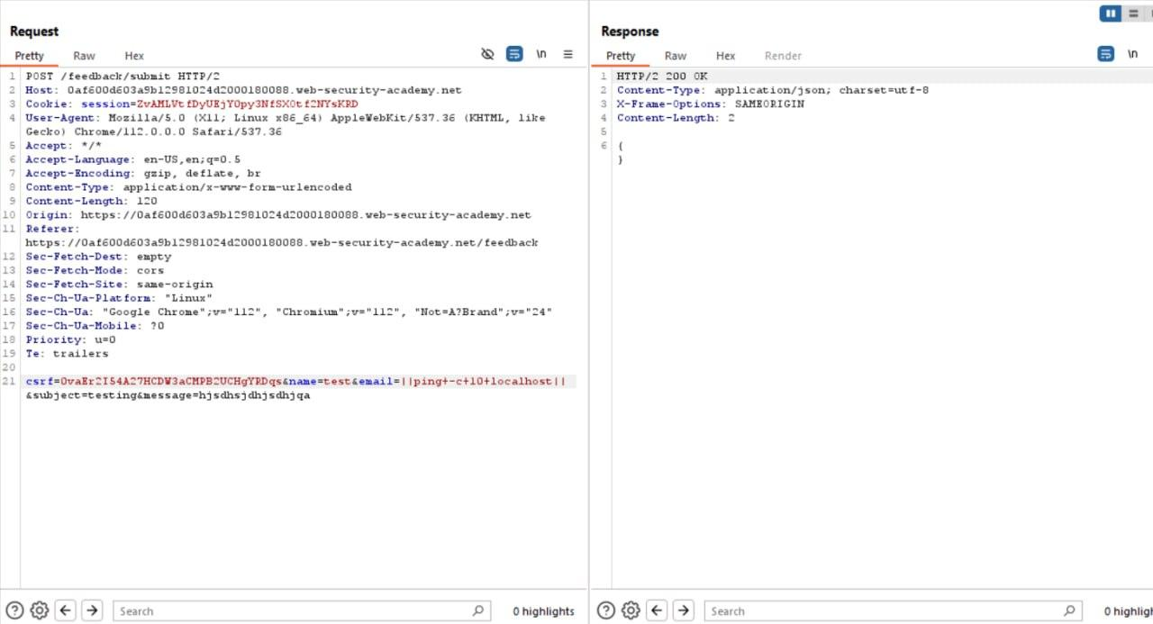

# Blind OS command injection with output redirection

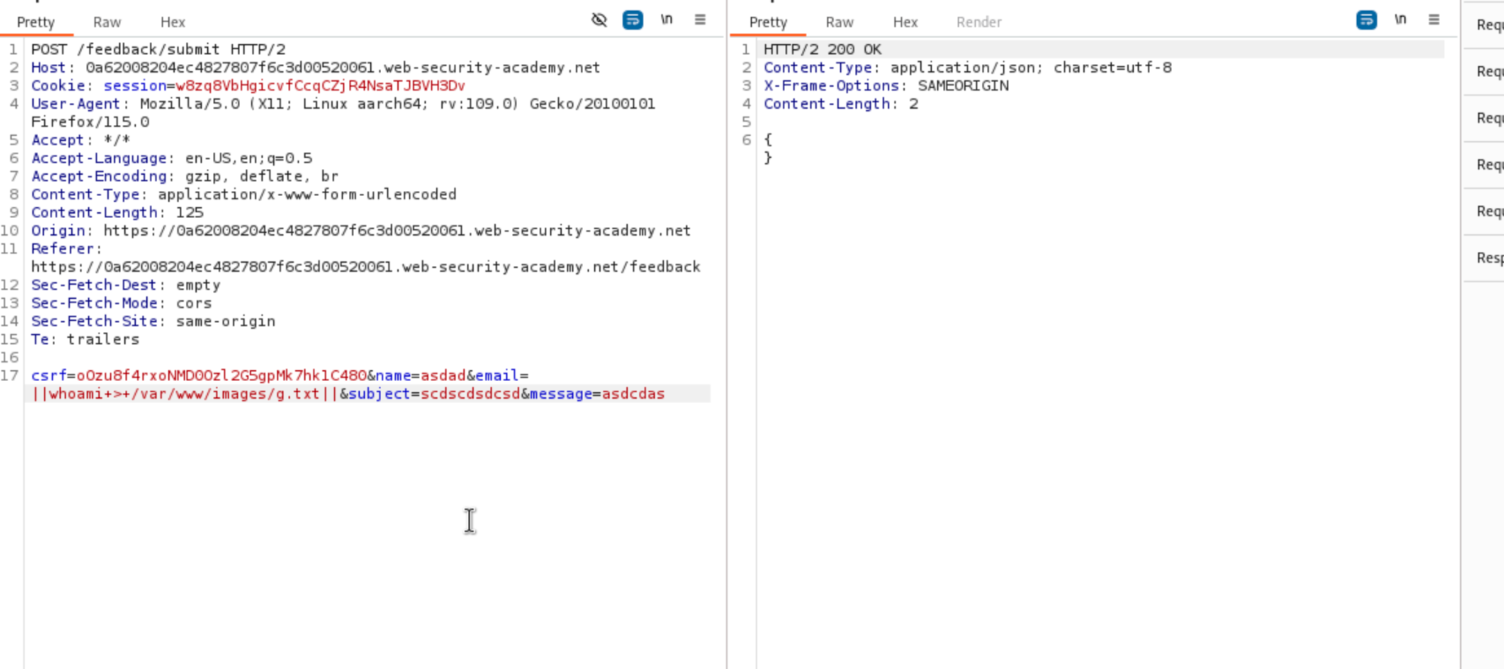

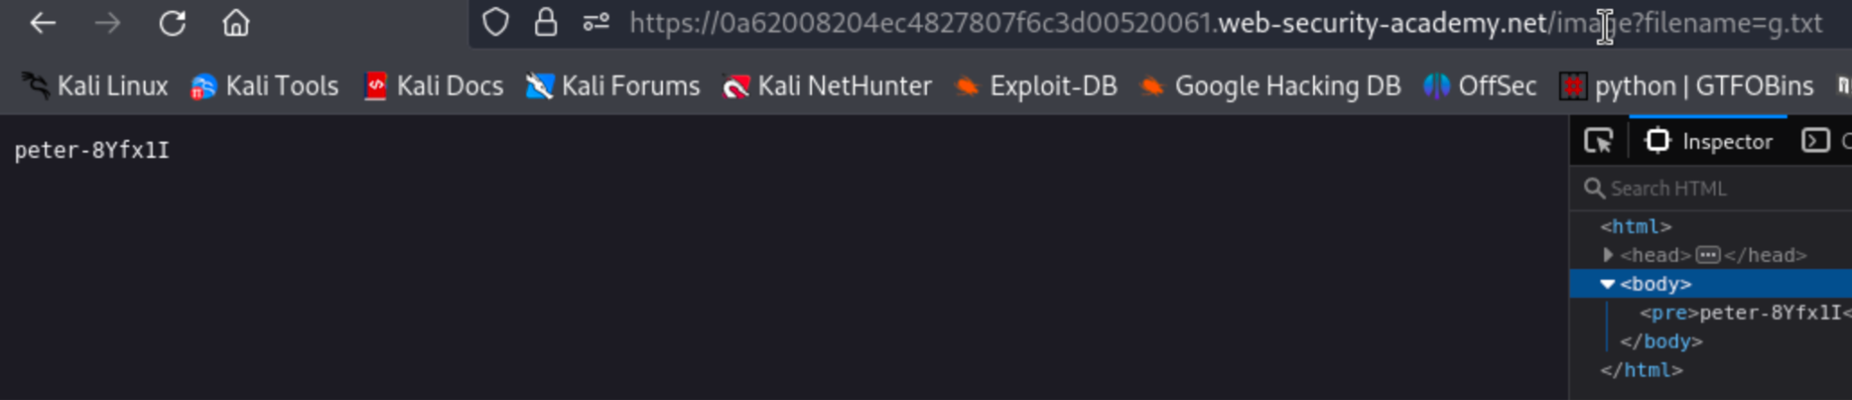

# 

# Web shell upload via path traversal

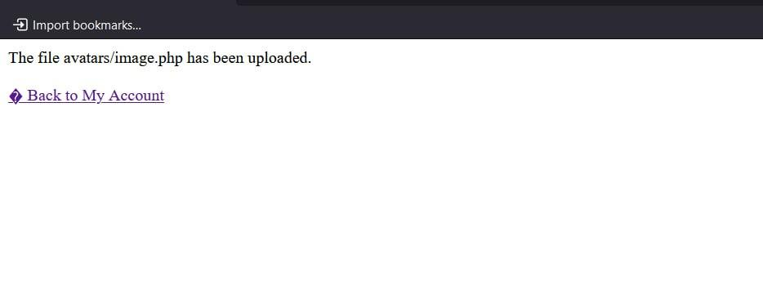

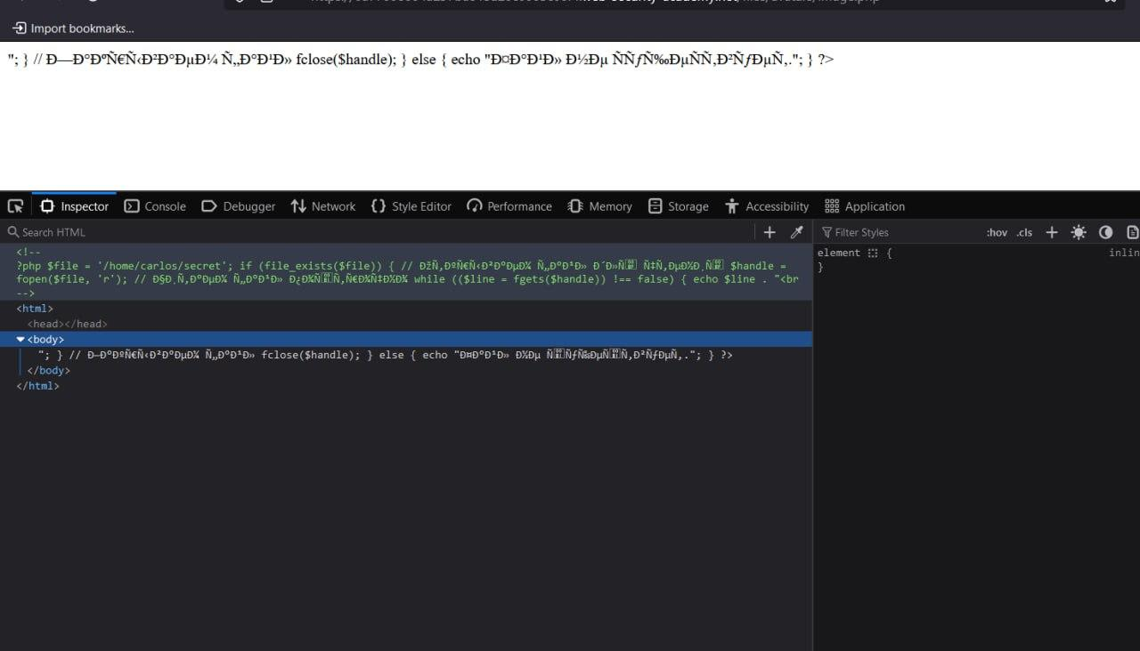

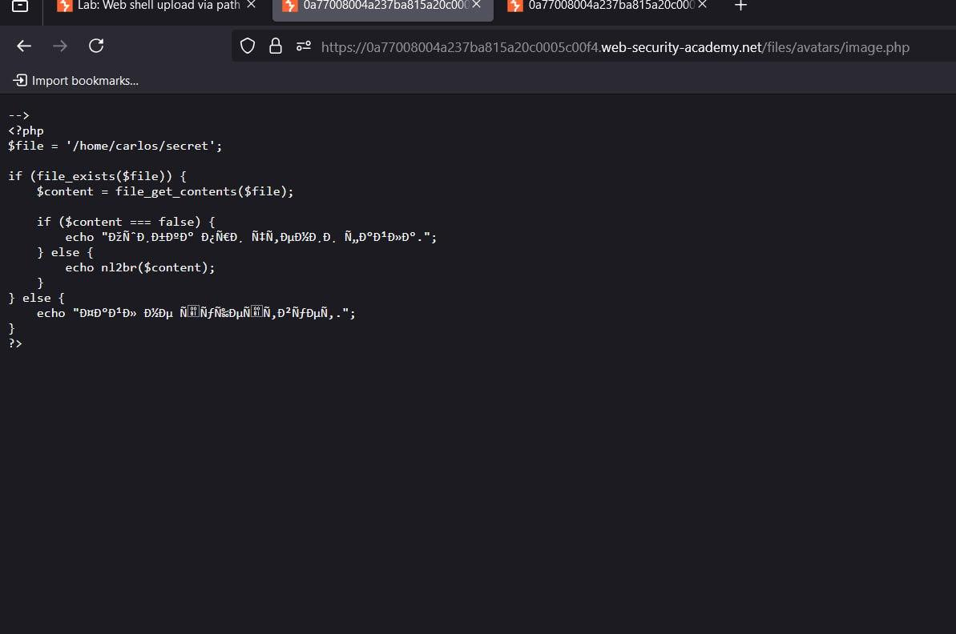

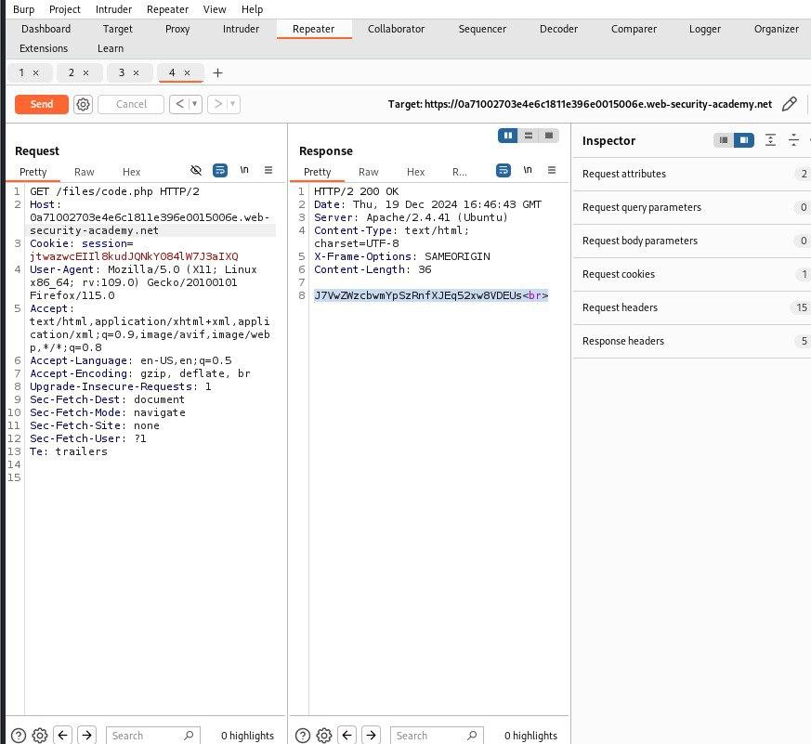

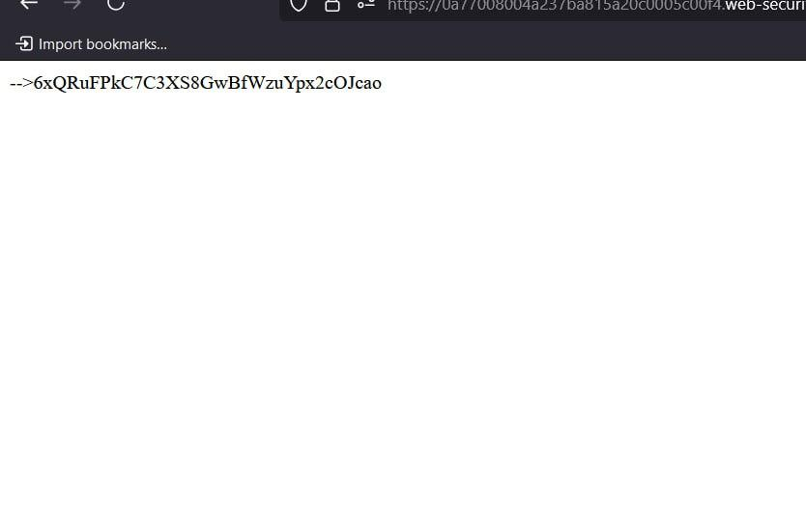

# Web shell upload via extension blacklist bypass

# 

# Basic server-side template injection (code context)

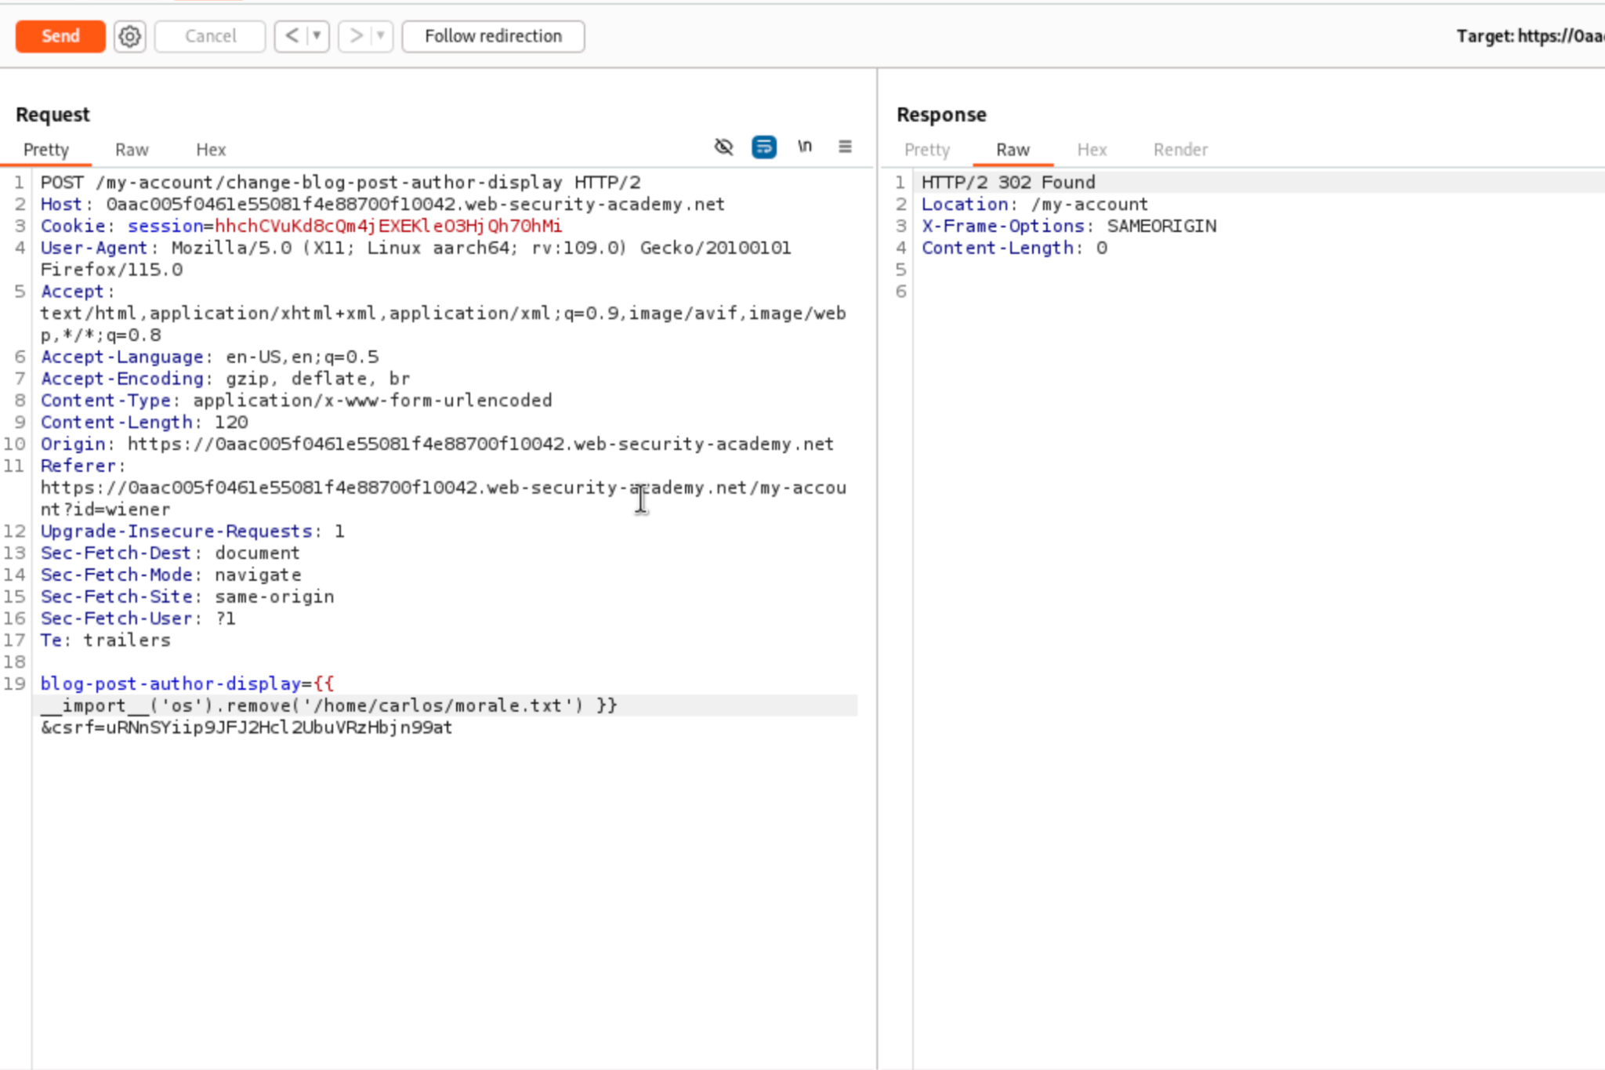

# 

# Basic server-side template injection

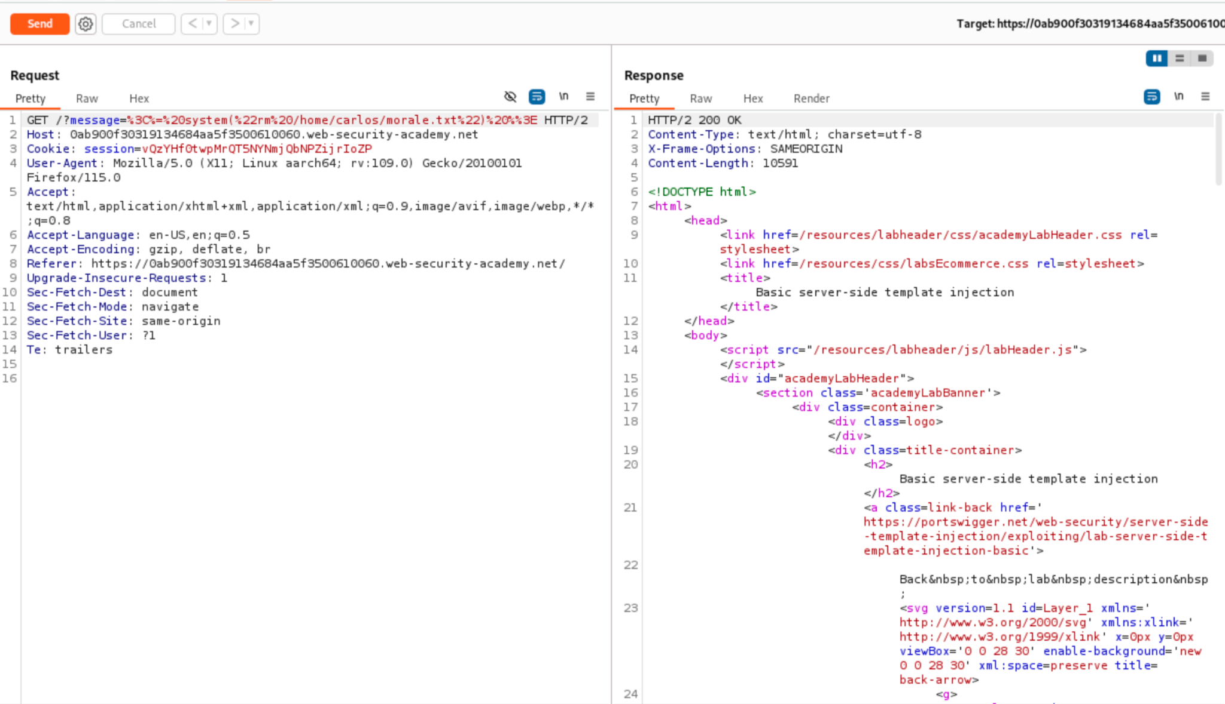

**Metasploitable - get root in 5 different ways**

Metasploitable is a deliberately vulnerable virtual machine designed for learning and testing security tools, such as Metasploit. It allows users to practice exploiting vulnerabilities in a controlled environment without breaking any laws.

Metasploitable includes several vulnerable services and applications, providing ample opportunities for conducting attacks. Below are some of the key components and vulnerabilities found in Metasploitable:

# Key Vulnerabilities in Metasploitable:

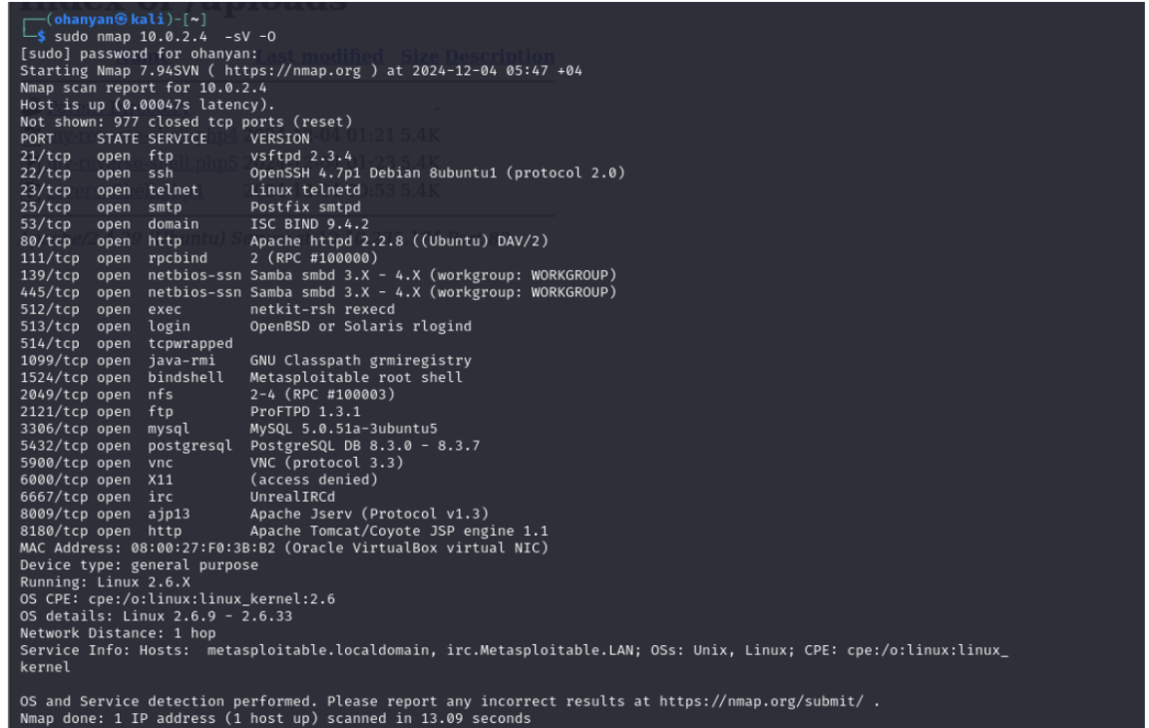

## **OpenSSH**:

* An outdated version of OpenSSH with vulnerabilities that can allow attackers to perform remote login attacks, such as password guessing or exploiting known exploits.

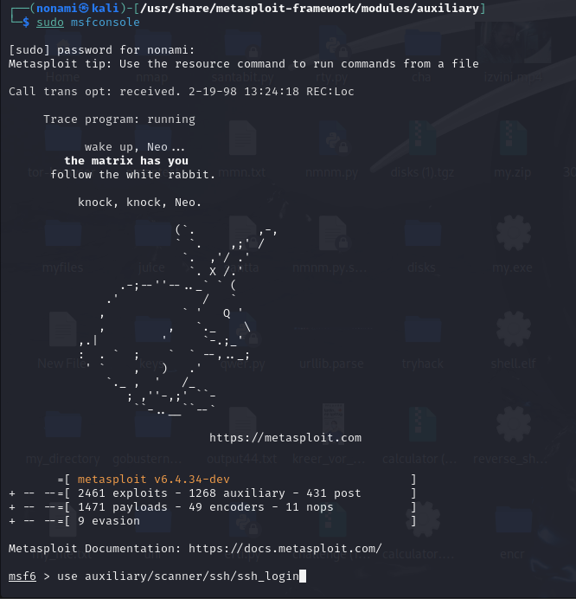

**set RHOSTS [target_IP]**

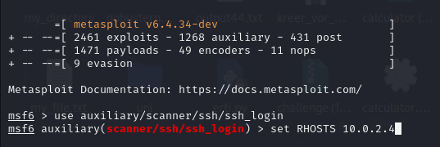

**Run**

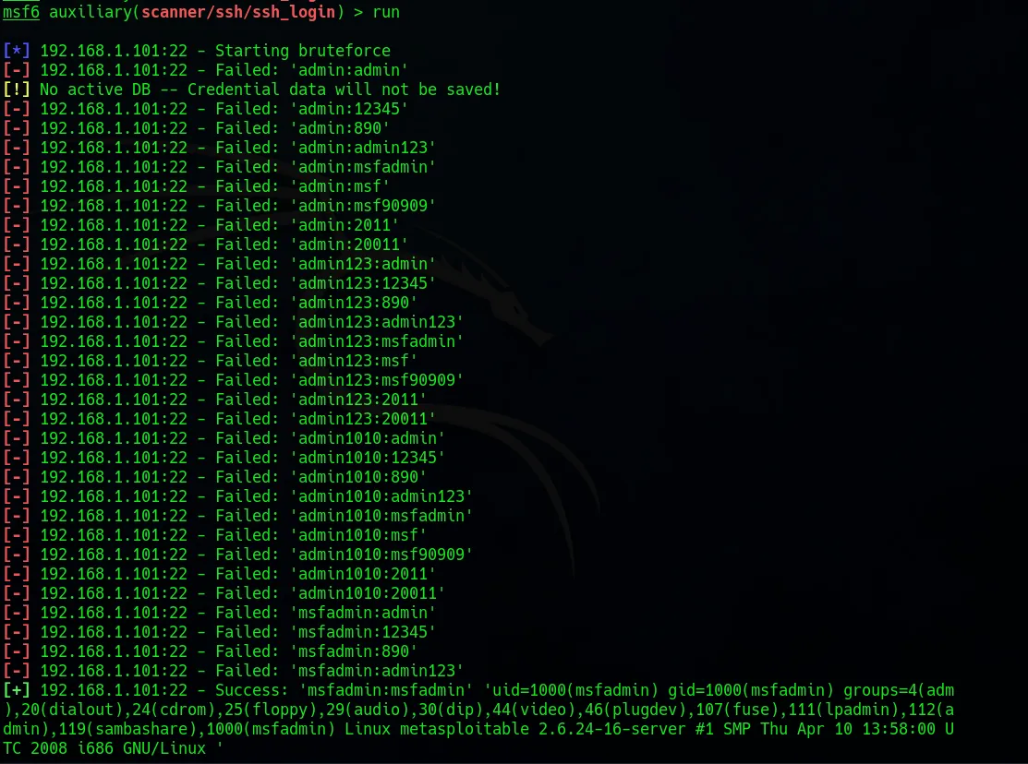

## **VsFTPd**:

* A vulnerability in the VsFTPd FTP server that could allow attackers to take control of the server.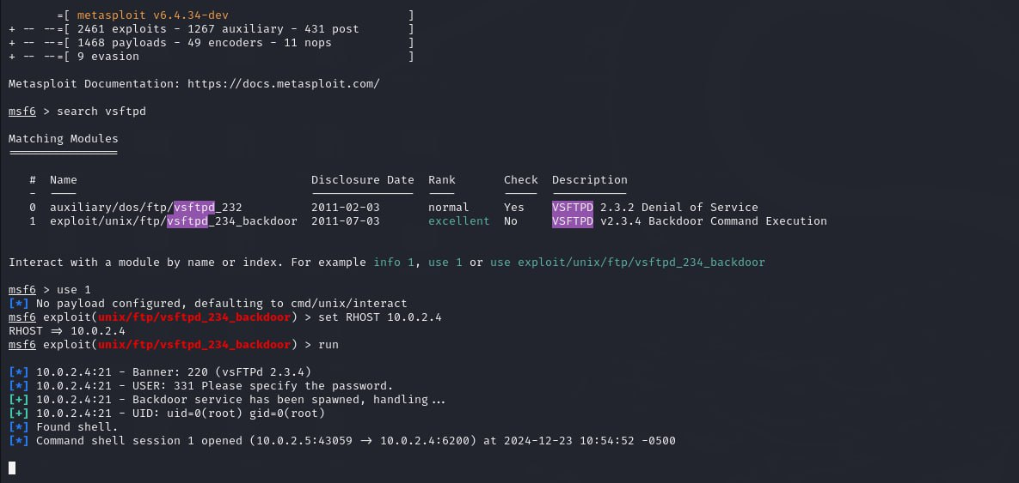

## **Samba**:

* Vulnerabilities in the Samba software that can be exploited through network shares for remote code execution.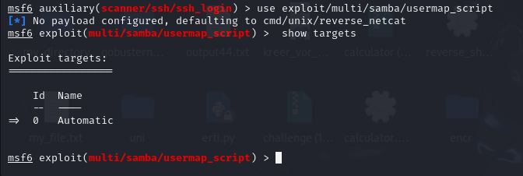

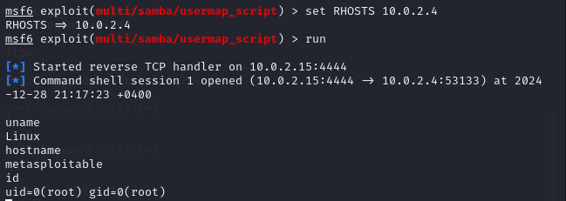

## **rLogin**:

* Old remote access protocol used to connect to a remote system over a network, similar to SSH but less secure.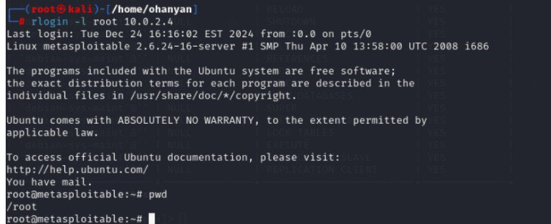

## **Telnet Login**:

* The telnet_login module in Metasploit is used for brute force password attacks on Telnet servers. It attempts to log in by trying various combinations of usernames and passwords from a provided wordlist. This module is useful for testing the security of Telnet servers and finding weak credentials.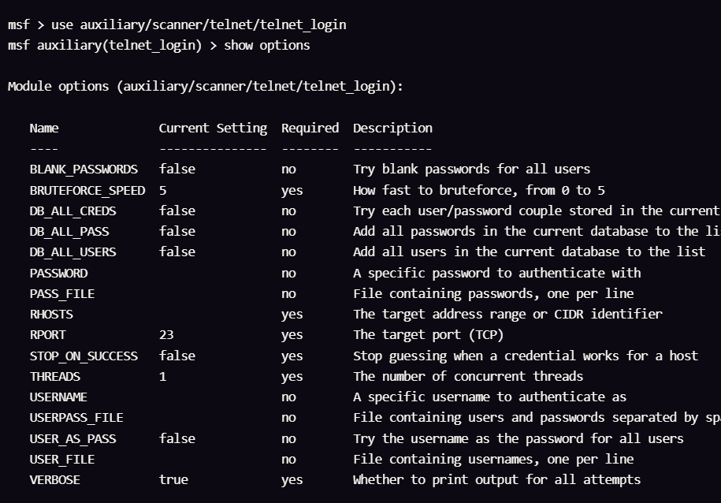

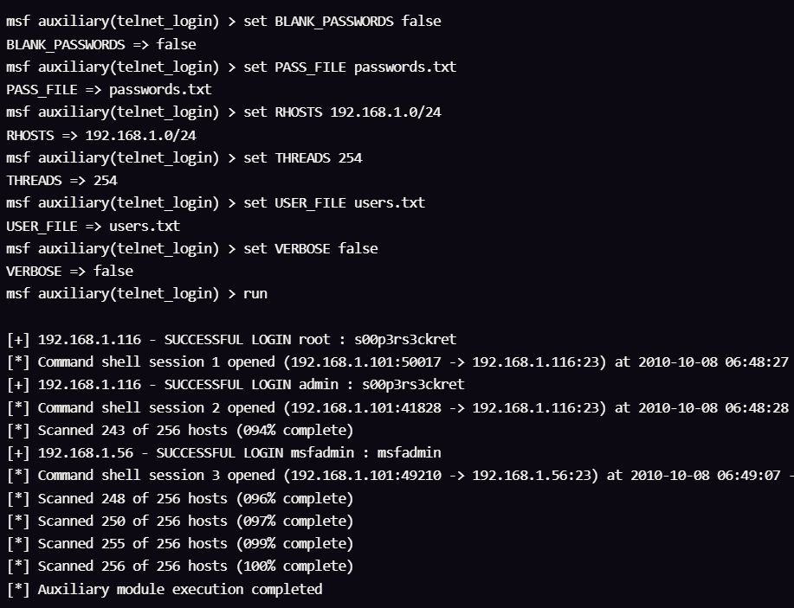

**Reverse shell payload in exe format, py format and bash format**

# Python Reverse Shell Payload

# Bash Reverse Shell Payload

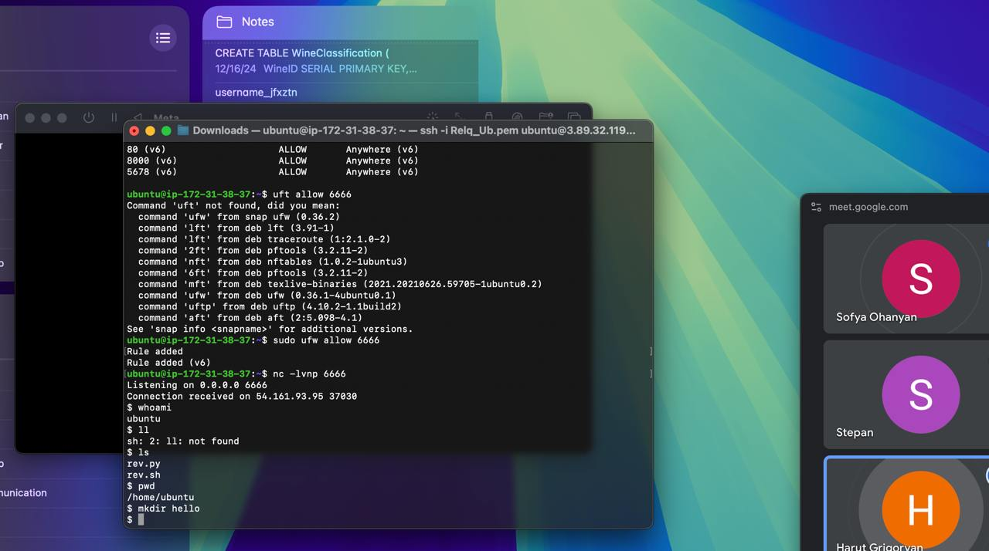

Check that file *‘hello’* has been created in target machine

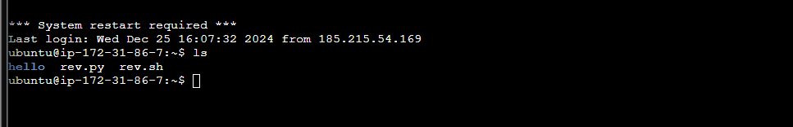

# EXE Reverse Shell Payload

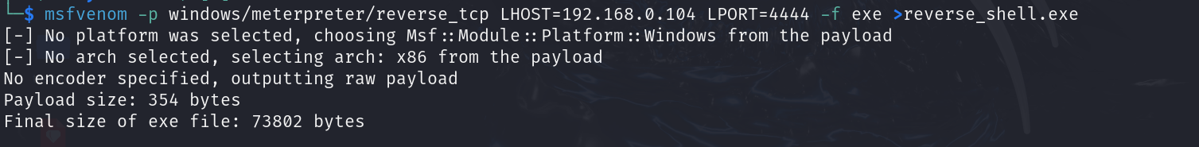



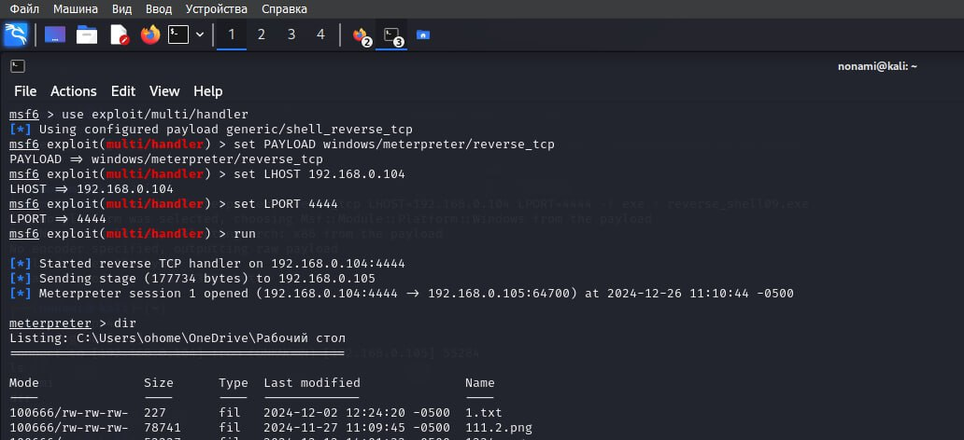

# 

# **Reverse Shell in Ruby**

This Ruby script demonstrates a basic reverse shell using object-oriented programming (OOP) principles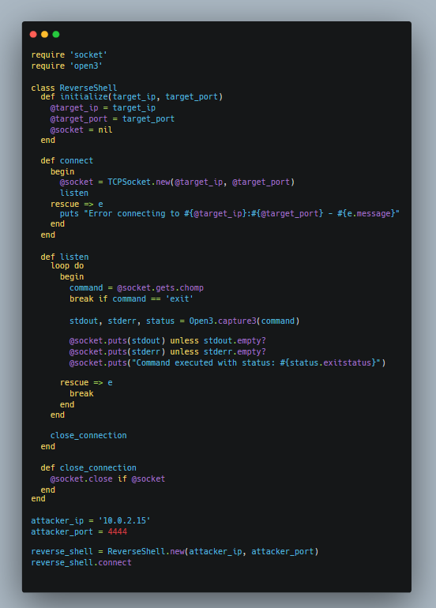

**ReverseShell Class Breakdown:**

1. **initialize**: This method is called when a new instance of the ReverseShell class is created. It takes the target's IP address and port as arguments.
2. **connect**: Attempts to establish a connection to the target IP and port using TCPSocket. If the connection is successful, it begins listening for commands.
3. **listen**: A loop that continuously waits for commands from the attacker. When a command is received, it executes it on the target machine and sends the output back to the attacker. If the command is exit, it terminates the loop.
4. **close_connection**: This method safely closes the socket connection to the attacker.

**Object-Oriented Concepts Used**

* **Encapsulation**: The ReverseShell class encapsulates all the logic related to the reverse shell. The instance variables (@target_ip, @target_port, @socket) hold the state of the reverse shell, and the methods (connect, listen, close_connection) define the behavior of the reverse shell.
* **Methods**: The methods (initialize, connect, listen, close_connection) define the functionality of the reverse shell, like establishing a connection, executing commands, and closing the connection.
* **Instance Variables**: The use of instance variables (@target_ip, @target_port, @socket) allows the class to maintain state across method calls. These variables store data that is specific to each object instance.
* **Object Creation**: The reverse shell is created as an object, which is instantiated with specific attributes (target_ip and target_port). Each object can have different values for these attributes, allowing multiple reverse shells to be created with different target IPs and ports.

**How to Use:**

1. **Target Setup**: Replace '10.0.2.15' with the IP address of the attacker's machine and set the listening port (e.g., 4444).
2. **Run the Attacker's Listener**: On the attacker's machine, use nc -lvp 4444 or a similar tool to listen for the incoming connection.
3. **Run the Reverse Shell**: Execute the script on the target machine, and it will attempt to connect back to the attacker. Any commands sent by the attacker will be executed on the target machine.

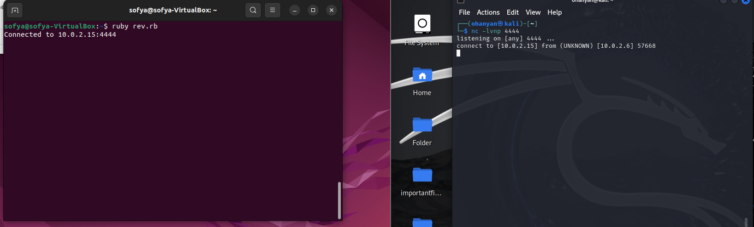

Any commands sent by the attacker will be executed on the target machine.

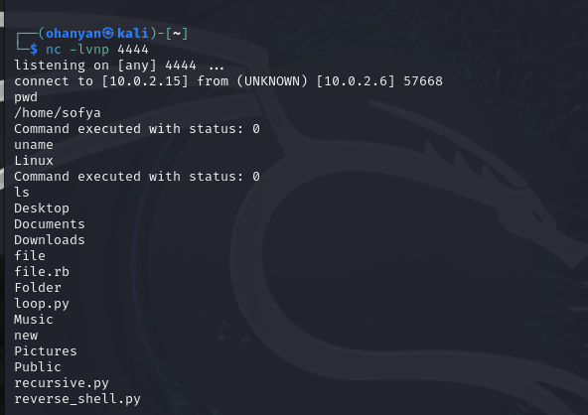

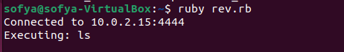

Create a file on target machine

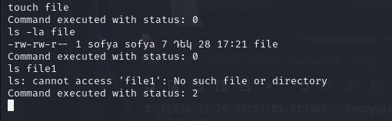

Check that the file has been created

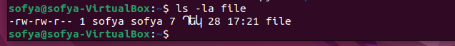

## 

# **Using searchsploit Instead of exploitdb for CVEs on a Metasploitable Machine**

**searchsploit**

* **Purpose**: searchsploit is a command-line tool that comes with the **Exploit Database** package. It allows you to search for and access the full exploit database on your local machine

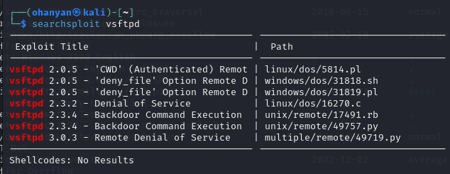

**mirrors (copies)** the specified exploit file from the local Exploit-DB repository to your current working direc

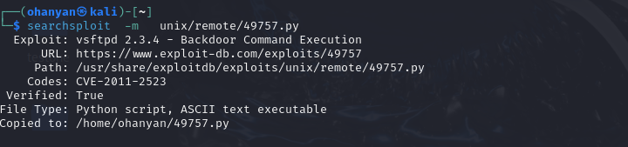

Run the exploit

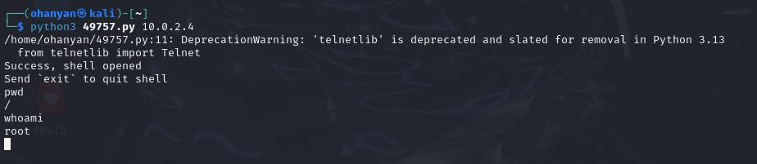

**ExploitDB**

* **Purpose**: **ExploitDB** is a public repository of **exploit** and **vulnerability** information. It is an online database maintained by the Offensive Security team. It is the source of both searchsploit and the Metasploit modules.

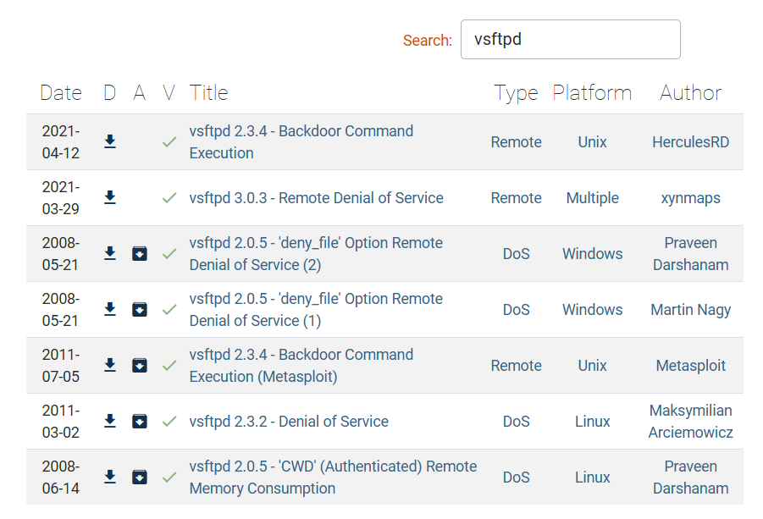

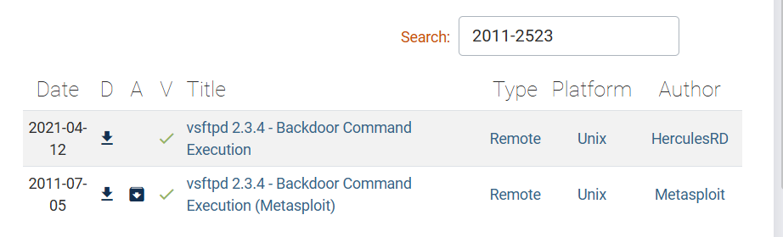

# 

# 

# **Finding the Location of Metasploit Scripts on Your Linux Machine**

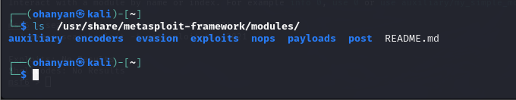

# **Writing a Simple Metasploit Module**

**Create a basic auxiliary module**

**Auxiliary Modules:**

* **Purpose:** Auxiliary modules are typically used for non-exploit tasks, like scanning, brute-forcing, or reconnaissance. They don't create a session or exploit a vulnerability to give you remote access directly.
* **Targeting:** Auxiliary modules often focus on **information gathering** or other tasks and do not directly attack a specific vulnerability.
* **Example:** A port scanner or vulnerability scanner module.

This Ruby code defines a **Metasploit auxiliary module** for Metasploit Framework, which is designed to demonstrate how to create custom modules

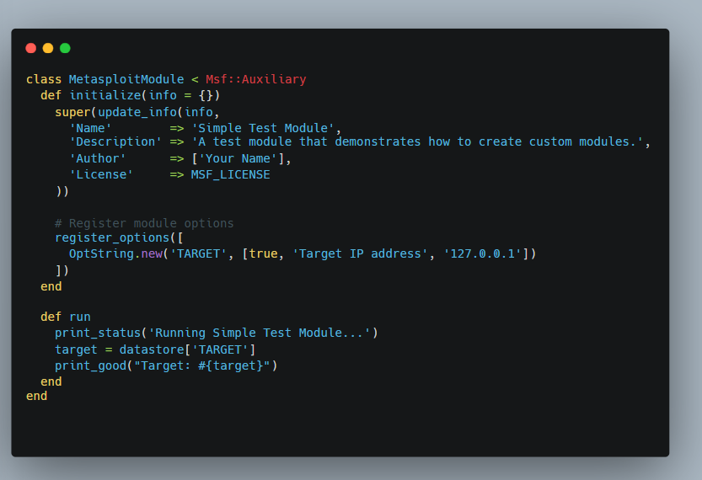

**Add Module to Metasploit**:

*cp my_simple_module.rb /usr/share/metasploit-framework/modules/auxiliary/*

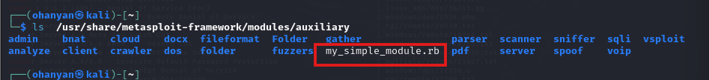

***Load the module into Metasploit:***

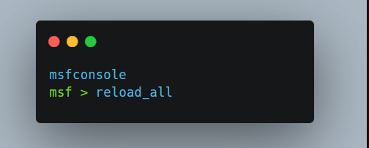

***Search module***

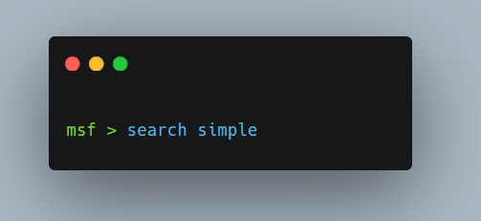

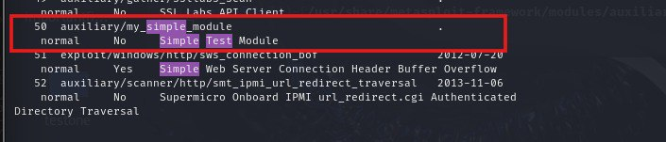

**Use the module**: 